Renju lesson on September 20, 2001
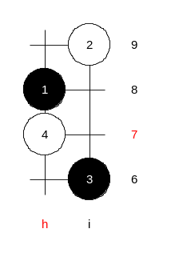
Hello everyone! Today we will begin with new opening. We have finished the study of d11. As we have democratic class, and your activity and interference is welcome and expected, I let you decide the new opening. Everyone can vote for one opening. Please do not vote for the opening that we have learned before at Playsite. Concord will count the votes.

Thank you all. You have voted for i8 opening. So will it be. We will begin with i8 opening. Short evaluation of opening, I will read it out from my new book opening introduction:
“Opening i8 is also considered as a very strong opening for black, however, it is not easy to make black advantage to become a victory. In fact, white often wins here due to black’s insufficient knowledge about theory. It takes much learning to become good at this opening. Moves 4-g8, 4-g9, 4-i10, 4-h9 offer very tough resistance. However, in case of series of correct black moves, black can always have a powerful advantage there.”

This was the intro of the i8 chapter in my new book.
Any questions about the evaluation part? Yusuke asks: “Isn’t h7 a strong 4th?”
To answer that, we could as well begin with that 4th move. The move 4-h7 in fact leads to i2/d2 opening. Do you all understand that? You just swap the 2nd and the 4th move and you get the d2 opening sequence. As I open my book from the i2/d2 opening, it says about the 4th move: “Black wins here without problems. Similar position also comes from i8 or i4 opening with different distance to the board edges, however the board edge cannot influence the win here nor in i8 opening.” (it was from the i2 chapter of the book).
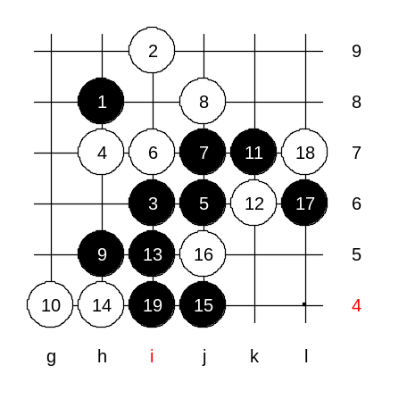
We will begin with the main 5th move. Which 6th move is the strongest? Indeed, 6-i7 is surely the strongest defense. The following moves a re very natural. Where would you play if you were black here? True, black j7, white j8. Move 9-h5 may need a short explanation. It forces white to play to g4 (irrelevant stone) and at the same time creates a potential four that is needed in the struggle against white counter-threes.
Move 15-j4 is a key move. 16-j5 loses as shown on diagram.

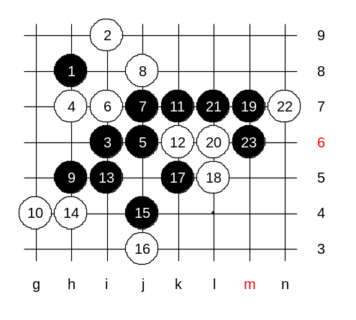
Lets also check the win in case of 16-j3.

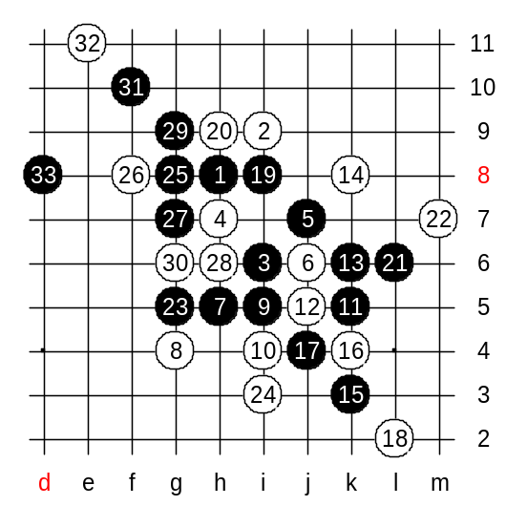
Let’s check the win of alternative 5th move, too. That variant is perhaps more well-known and occurs in most of theory books, but let us review it once again. 5-j7 is the winning alternative. Speaking of 5-g6, the old theory did not appreciate it very much, but the modern analysis and the tactics of positional style proves black big advantage there, too.
Lets go back to 5-j7.

This is so famous variant, I guess most of you know it well.
Beautiful win at 33rd move!

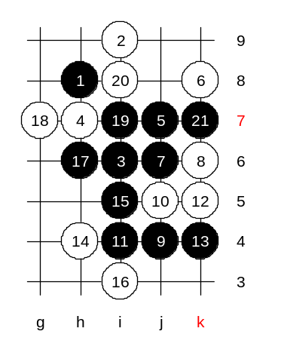
Another 6th move.
The 9-j4 is the correct move. I had made some corrections to the old theory book, to make the win surer. Beautiful 21st move gives black win. All white active material is under the control.

This is the end of 4-h7. It died fast.
Next week, the other 4th moves will be studied.

